**Auto Mail Triggering After Test**

After Running All our Test, we are Configuring Auto reports sending process Through mail.

Contents

* **Process of Mail triggering**
* **Configuration with Project**
* **Process of Mail triggering**

**Copy SendingMail.java file from below link and Copy to your base project Application package.**

**\\192.168.10.216\MahiShare\ReportAndMail\Reporting**

**Add below Maven dependency to Your base Project and import references for Extent report.**

<dependency>

<groupId>com.sun.mail</groupId>

<artifactId>javax.mail</artifactId>

<version>1.6.2</version>

</dependency>

**Java introduced javax.mail package for auto mail sending process ,**

**In this package we can find Session Creation, Mail body Forming, attach files, And Mail send Function.**

**How exactly Auto Mail Trigger will work!!!**



**Auto mail Sending Process.**

* **First, we are connecting to Mail server of the Organization by using server authentication.**

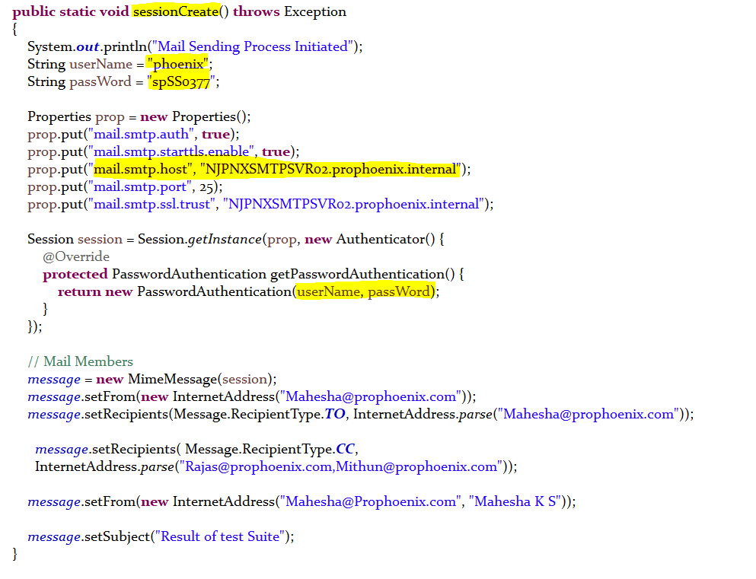

* **And We are Assigning From -To Mail address and CC, BCC if needed.**

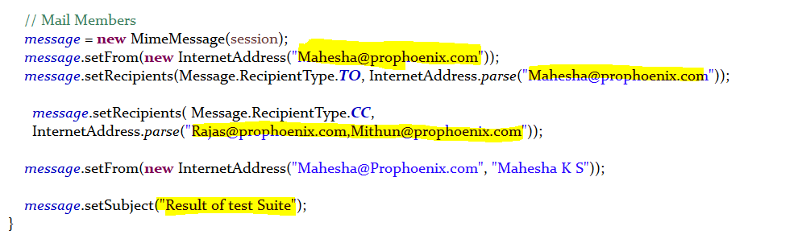

* **Attaching Mail Body , Report files path to send.**

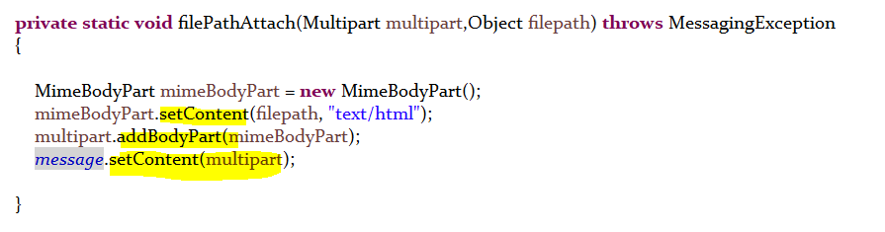

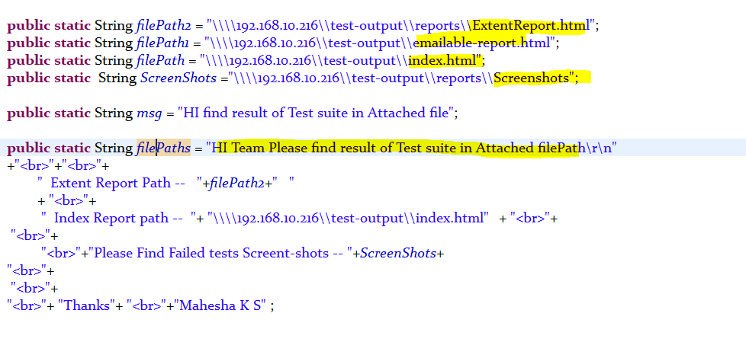

* **Sending Mail**

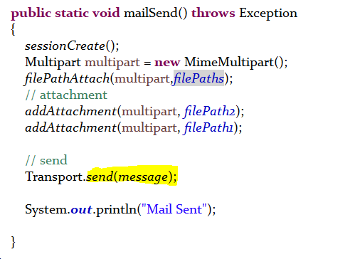

**Let’s See How We Configure With our Test Scripts**

* **Configuration with Test scripts**
* **After Running All our Scripts after Generating the reports We should Mentions the Path of the Report files Inside Sending Mail java class.**
* **And we should call mailSend() function inside AfterSuite function, So that At the end of the test will send reports mail to mentioned MailID.**

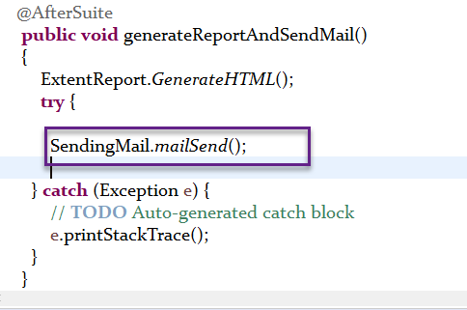

End

**Thanks**

**Mahesha K S**